## Feature Requests

Zerto allows Cloud Providers and Enterprise customers to personally request ideas or features that they wish to have added into the product. This is done through myZerto.com’s dedicated Feature Request page. Once the idea or feature is submitted, other users can login to the myZerto portal and vote on the idea themselves. The more votes that Zerto receives on a feature, the higher it will be prioritized on our roadmap. If you have any ideas for additions to Zerto’s products, we highly recommend that you either submit a new request or vote on the current request for feature you want to have added to Zerto’s product.

Additionally, if there is an idea in place that you have voted on and would like to monitor the process of, you can subscribe to the request and receive updates. Subscribing to a Feature Request will send the user email updates when a Zerto Product Manager or other myZerto users comment on its status. It will also alert users if the request is marked as planned, shipped (implemented), will not implement (with explanation), or already exists. The subscribe button can be found on the Feature Request itself, seen below:

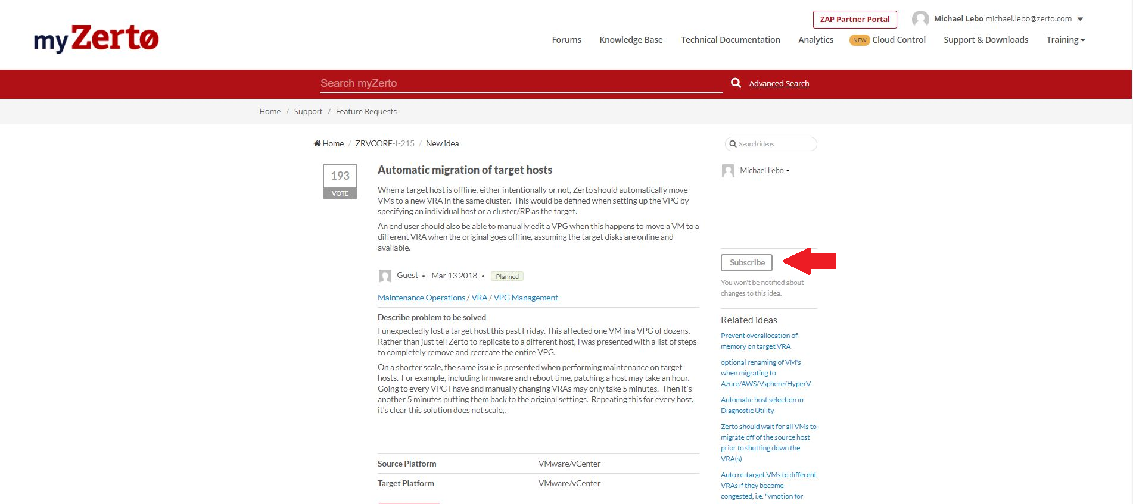

Feature Request Submission Process:

1. Navigate to the myZerto.com site and login with your credentials
2. Once logged in, navigate to the “Support & Downloads” tab on the top right:

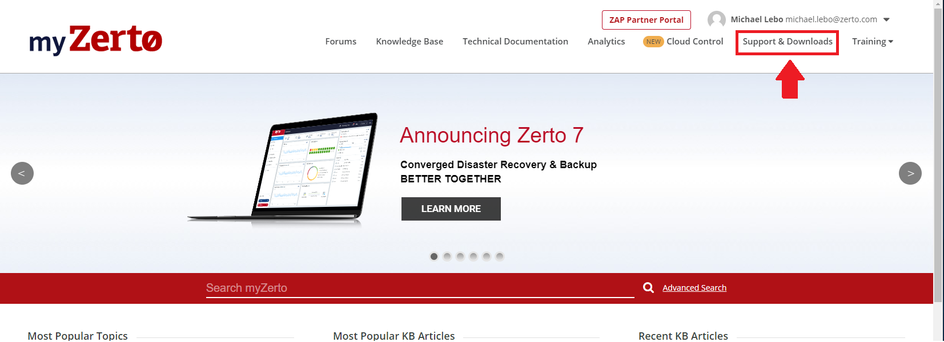

1. On this page you will have multiple options for downloading Zerto files, creating Support cases and more. Select the Feature Request option from this page:

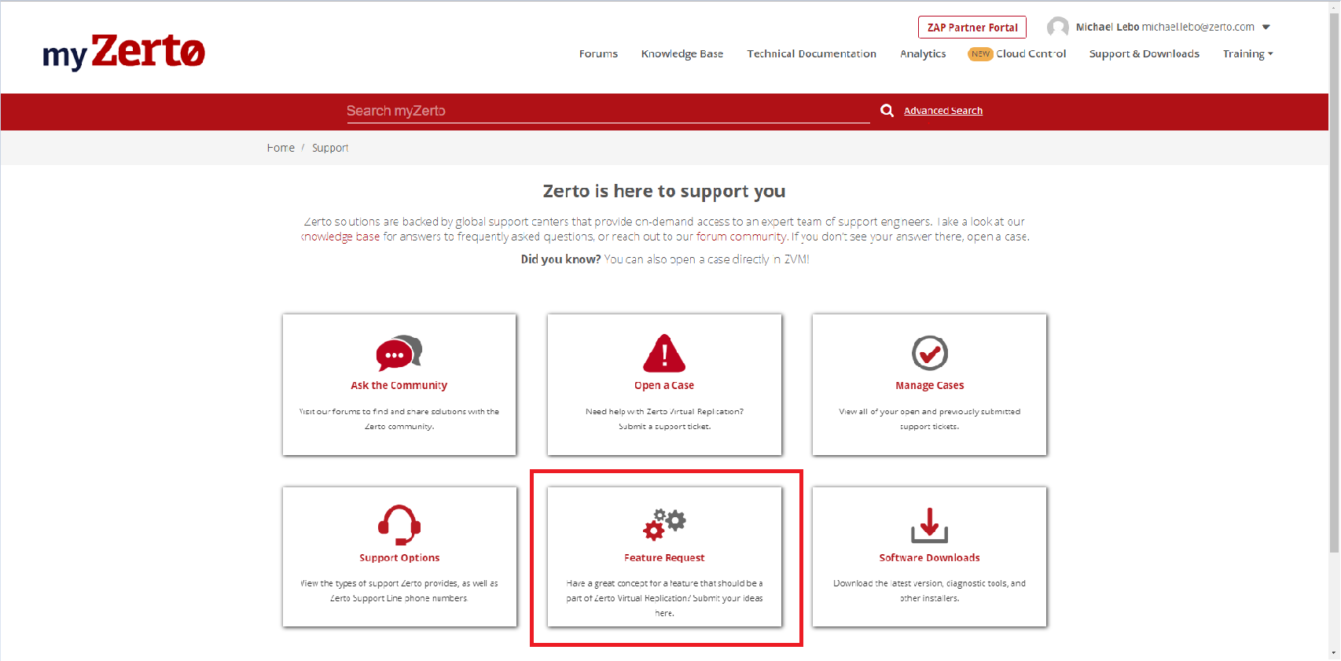

1. On the Feature Request page, you will see a searchable list of the current requests. Always search the list for your idea first and ensure that the request has not already been created. If you find that the request is there, simply vote on the request and Zerto’s Product Manager team will be alerted. If the idea is not on the list, select the “Add a new idea” button on the top left-hand side of the page:

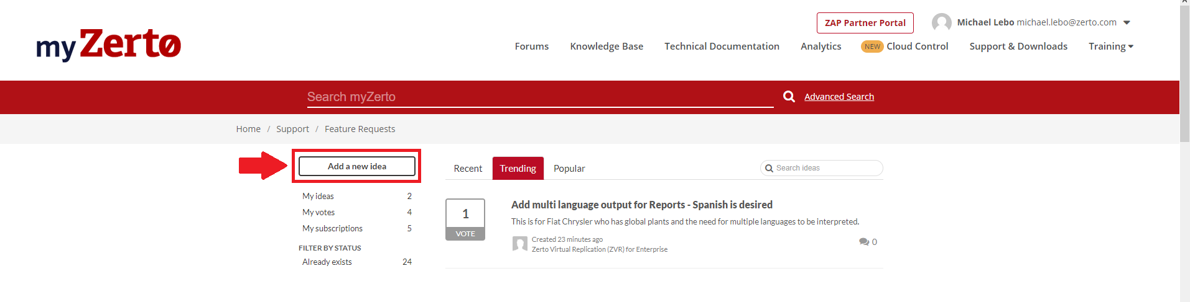

1. Now that you are on the add a new idea page, you can then fill out the form accordingly. Make sure to be clear and concise when creating a title, ensuring that the feature can be easily found during searches. The same goes for the description too:

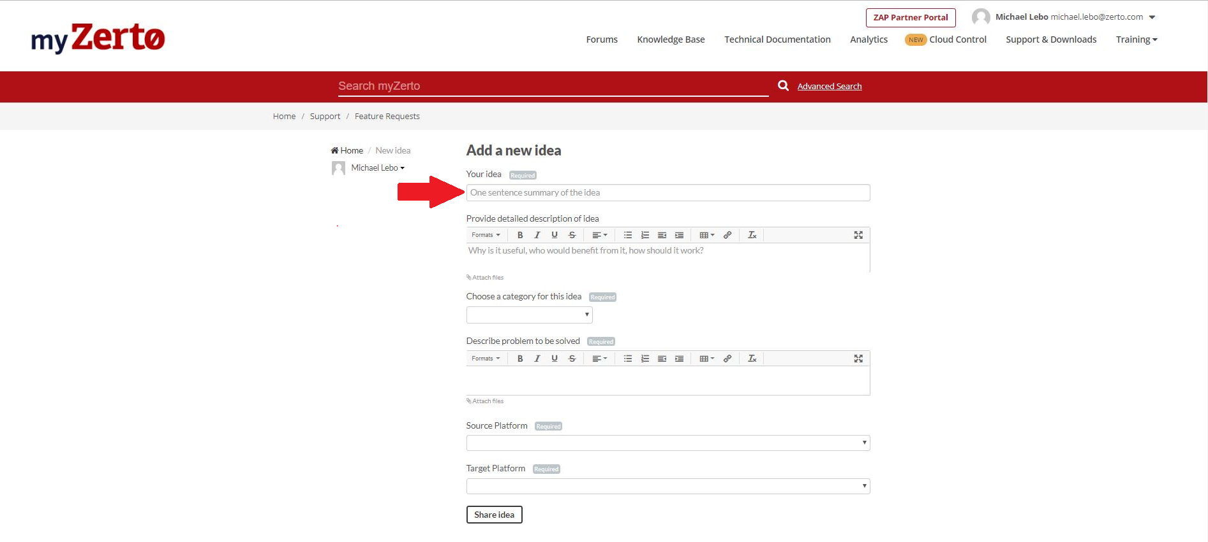

1. Once the form is filled out, you can submit the idea via the “Share idea” button at the bottom of the page. The idea will be sent, and our Product Managers will be alerted. The idea has now been added to the searchable list on the Feature Request page, allowing any other users to vote on it, pushing the idea further up the list of Zerto’s roadmap.